Digital Computer Logic

Uzair Mehmood

Registration No

Digital Computer Logic

Light Detector



**DEPARTMENT OF SOFTWARE ENGINEERING**

SEMESTER PROJECT

ON

**“LIGHT DETECTOR”**

Submitted By:

Submitted to:

Contents

**Project Description:** 3

Introduction: 3

Component Required: 3

Working: 4

Circuit Diagram: 5

Applications: 6

**Project Detail:** 6

Integrated Circuit: 6

LM358 OP – Amp IC: 8

Light Dependent Resistor (Photo Resistor): 9

Design Consideration: 10

Applications: 11

Resistor: 12

Power Dissipation: 13

Adjustable resistors: 14

Resistance decade boxes: 15

Special devices: 15

Measurement: 16

Color Code: 17

Potentiometer: 18

Construction: 20

10K Potentiometer: 23

White Light Emitting Diode: 24

Wires: 25

Power Supply: 25

9V Battery: 27

**Project Cost:** 29

# **Project Description:**

## Introduction:

A Light Detector or a Light Sensor is a device or circuit that detects the intensity of the light incident on it. Different types of light detectors are LDRs (or Light Dependent Resistors), Photo Diodes, Photo Transistors, etc.

All these devices are called as Photoelectric Devices as they convert light energy to electric energy. These Light Detectors or Sensors can detect different types of light like visible light, ultraviolet light, infrared light etc.

In this project, we have designed a simple Light Detector using LDR. When the light falls on the LDR, the light stays off and when the light stops falling on LDR, the LED glows. We have designed two types of circuits: one using an OP – AMP (Operational Amplifier) and other using just transistors.

## Component Required:

* LM358 OP – Amp IC
* Small LDR
* 10 KΩ Resistor
* 10 KΩ Potentiometer
* White LED
* 220 Ω Resistor
* Connecting wires
* Power supply (9V Battery)

## Working:

The main components of the project are LM358 Op – Amp and LDR. First let us see about LDR (Light Dependent Resistor). An LDR, as the name suggests, is a type of resistor, whose resistance changes depending on the intensity of the light surrounding it.

Typically, when light is incident directly on the LDR, its resistance will be very low and when there is no light i.e. in darker conditions, its resistance jumps to few mega Ohms.

We will use this feature of the LDR is our project to detect light and turn on an LED. For this we have used an Operational Amplifier. The Op – Amp is configured in Comparator mode i.e. it will compare the voltages at inverting and non – inverting terminals and correspondingly generate a HIGH or LOW output.

We have connected the wiper terminal of the 10 KΩ Potentiometer to the inverting terminal of the OP – Amp. To the non – inverting terminal, we have connected the junction of a 10 KΩ Resistor and the LDR. These two will form a potential divider feeding its output to the OP – Amp.

When the light is incident on the LDR, its resistance decreases. Hence, the non – inverting voltage is lower than the inverting voltage and as a result, the LED remains OFF.

When there is no light falling on the LDR, the resistance of the LDR becomes very high and as a result, the voltage at the non – inverting terminal will be more than the voltage at inverting terminal. The output of the Op – Amp will be high and the LED is turned ON.

## Circuit Diagram:

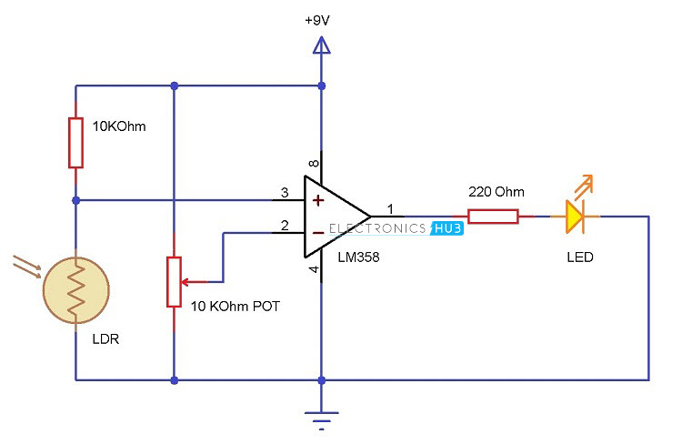

## Applications:

* Simple Light Detector Circuit can be used in many applications like automatic switching of appliances up on detecting light, security systems, etc.
* This circuit can be used in alarm system, where increasing intensity of light will trigger the alarm.
* It can also be used in cupboards or wardrobes. When the door is opened, the light will automatically turned on.

# **Project Detail:**

## Integrated Circuit:

An integrated circuit or monolithic integrated circuit (also referred to as an IC, a chip, or a microchip) is a set of [electronic circuits](https://en.wikipedia.org/wiki/Electronic_circuit) on one small flat piece of [semiconductor](https://en.wikipedia.org/wiki/Semiconductor) material, normally [silicon](https://en.wikipedia.org/wiki/Silicon). The integration of large numbers of tiny [transistors](https://en.wikipedia.org/wiki/Transistor) into a small chip results in circuits that are orders of magnitude smaller, cheaper, and faster than those constructed of discrete [electronic components](https://en.wikipedia.org/wiki/Electronic_component). The IC's [mass production](https://en.wikipedia.org/wiki/Mass_production) capability, reliability and building-block approach to [circuit design](https://en.wikipedia.org/wiki/Integrated_circuit_design) has ensured the rapid adoption of standardized ICs in place of designs using discrete transistors. ICs are now used in virtually all electronic equipment and have revolutionized the world of [electronics](https://en.wikipedia.org/wiki/Electronics). [Computers](https://en.wikipedia.org/wiki/Computer), [mobile phones](https://en.wikipedia.org/wiki/Mobile_phone), and other digital [home appliances](https://en.wikipedia.org/wiki/Home_appliance) are now inextricable parts of the structure of modern societies, made possible by the small size and low cost of ICs.

Integrated circuits were made practical by mid-20th-century technology advancements in [semiconductor device fabrication](https://en.wikipedia.org/wiki/Semiconductor_device_fabrication). Since their origins in the 1960s, the size, speed, and capacity of chips have progressed enormously, driven by technical advances that fit more and more transistors on chips of the same size - a modern chip may have several billion [transistors](https://en.wikipedia.org/wiki/Transistor) in an area the size of a human fingernail. These advances, roughly following [Moore's law](https://en.wikipedia.org/wiki/Moore%27s_law), make computer chips of today possess millions of times the capacity and thousands of times the speed of the computer chips of the early 1970s.

ICs have two main advantages over [discrete circuits](https://en.wikipedia.org/wiki/Discrete_circuit): cost and performance. Cost is low because the chips, with all their components, are printed as a unit by [photolithography](https://en.wikipedia.org/wiki/Photolithography) rather than being constructed one transistor at a time. Furthermore, packaged ICs use much less material than discrete circuits. Performance is high because the IC's components switch quickly and consume comparatively little power because of their small size and close proximity. The main disadvantage of ICs is the high cost to design them and fabricate the required [photomasks](https://en.wikipedia.org/wiki/Photomask). This high initial cost means ICs are only practical when [high production volumes](https://en.wikipedia.org/wiki/Mass_production) are anticipated.

### LM358 OP – Amp IC:

The LM358 IC is a great, low power and easy to use dual channel op-amp IC. It is designed and introduced by national semiconductor. It consists of two internally frequency compensated, high gain, independent op-amps. This IC is designed for specially to operate from a single power supply over a wide range of voltages. The LM358 IC is available in a chip sized package and [applications of this op amp include](https://www.elprocus.com/op-amp-applications-in-electronics/) conventional op-amp circuits, DC gain blocks and transducer amplifiers. LM358 IC is a good, standard [operational amplifier](https://www.elprocus.com/operational-amplifiers/) and it is suitable for your needs. It can handle 3-32V DC supply & source up to 20mA per channel. This op-amp is apt, if you want to operate two separate op-amps for a single power supply. It’s available in an 8-pin DIP package.

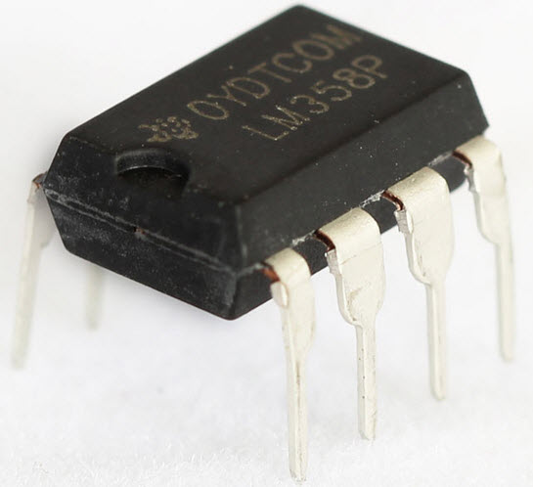

## Light Dependent Resistor (Photo Resistor):

A photo resistor (or light-dependent resistor, LDR, or photo-conductive cell) is a light-controlled variable [resistor](https://en.wikipedia.org/wiki/Resistor). The [resistance](https://en.wikipedia.org/wiki/Electrical_resistance) of a photo resistor decreases with increasing incident light intensity; in other words, it exhibits [photoconductivity](https://en.wikipedia.org/wiki/Photoconductivity). A photo resistor can be applied in light-sensitive detector circuits, and light-activated and dark-activated switching circuits.

A photo resistor is made of a high resistance [semiconductor](https://en.wikipedia.org/wiki/Semiconductor). In the dark, a photo resistor can have a resistance as high as several me ohms (MΩ), while in the light, a photo resistor can have a resistance as low as a few hundred ohms. If incident light on a photo resistor exceeds a certain [frequency](https://en.wikipedia.org/wiki/Frequency), [photons](https://en.wikipedia.org/wiki/Photon) absorbed by the semiconductor give bound [electrons](https://en.wikipedia.org/wiki/Electron) enough energy to jump into the [conduction band](https://en.wikipedia.org/wiki/Conduction_band). The resulting free electrons (and their [hole](https://en.wikipedia.org/wiki/Electron_hole) partners) conduct electricity, thereby lowering [resistance](https://en.wikipedia.org/wiki/Electrical_resistance). The resistance range and sensitivity of a photo resistor can substantially differ among dissimilar devices. Moreover, unique photo resistors may react substantially differently to photons within certain wavelength bands.

A photoelectric device can be either intrinsic or extrinsic. An intrinsic semiconductor has its own [charge carriers](https://en.wikipedia.org/wiki/Charge_carrier) and is not an efficient semiconductor, for example, silicon. In intrinsic devices the only available electrons are in the [valence band](https://en.wikipedia.org/wiki/Valence_band), and hence the photon must have enough energy to excite the electron across the entire [bandgap](https://en.wikipedia.org/wiki/Bandgap). Extrinsic devices have impurities, also called [dopants](https://en.wikipedia.org/wiki/Dopants), added whose ground state energy is closer to the conduction band; since the electrons do not have as far to jump, lower energy photons (that is, longer wavelengths and lower frequencies) are sufficient to trigger the device. If a sample of silicon has some of its atoms replaced by phosphorus atoms (impurities), there will be extra electrons available for conduction. This is an example of an extrinsic semiconductor.

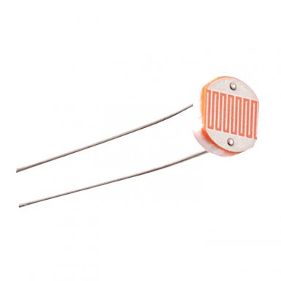

### Design Consideration:

Photo resistors are less light-sensitive devices than [photodiodes](https://en.wikipedia.org/wiki/Photodiode) or [phototransistors](https://en.wikipedia.org/wiki/Phototransistor): the two latter components are true [semiconductor devices](https://en.wikipedia.org/wiki/Semiconductor_device), while a photo resistor is a passive component and does not have a [PN-junction](https://en.wikipedia.org/wiki/P%E2%80%93n_junction). The photo resistivity of any photo resistor may vary widely depending on ambient temperature, making them unsuitable for applications requiring precise measurement of or sensitivity to light photons.

Photo resistors also exhibit a certain degree of [latency](https://en.wikipedia.org/wiki/Latency_(engineering)) between exposure to light and the subsequent decrease in resistance, usually around 10 milliseconds. The lag time when going from lit to dark environments is even greater, often as long as one second. This property makes them unsuitable for sensing rapidly flashing lights, but is sometimes used to smooth the response of audio signal compression.

### Applications:

Photo resistors come in many types. Inexpensive [cadmium sulfide](https://en.wikipedia.org/wiki/Cadmium_sulfide) cells can be found in many consumer items such as camera light meters, clock radios, [alarm devices](https://en.wikipedia.org/wiki/Alarm_devices) (as the detector for a light beam), [nightlights](https://en.wikipedia.org/wiki/Nightlight), outdoor clocks, solar street lamps and solar road studs, etc.

Photo resistors can be placed in streetlights to control when the light is on. Ambient light falling on the photo resistor causes the streetlight to turn off. Thus energy is saved by ensuring the light is only on during hours of darkness.

They are also used in some [dynamic compressors](https://en.wikipedia.org/wiki/Dynamic_range_compression) together with a small [incandescent](https://en.wikipedia.org/wiki/Incandescent_lamp) or [neon](https://en.wikipedia.org/wiki/Neon) [lamp](https://en.wikipedia.org/wiki/Neon_lamp), or [light-emitting diode](https://en.wikipedia.org/wiki/Light-emitting_diode) to control gain reduction. A common usage of this application can be found in many [guitar amplifiers](https://en.wikipedia.org/wiki/Guitar_amplifiers) that incorporate an onboard [tremolo](https://en.wikipedia.org/wiki/Tremolo_(electronic_effect)) effect, as the oscillating light patterns control the level of signal running through the amp circuit.

The use of CdS and [CdSe](https://en.wikipedia.org/wiki/Cadmium_selenide) photo resistors is severely restricted in Europe due to the [RoHS](https://en.wikipedia.org/wiki/Restriction_of_Hazardous_Substances_Directive) ban on [cadmium](https://en.wikipedia.org/wiki/Cadmium).

[Lead sulfide](https://en.wikipedia.org/wiki/Lead(II)_sulfide) (PbS) and [indium antimonide](https://en.wikipedia.org/wiki/Indium_antimonide) (InSb) LDRs (light-dependent resistors) are used for the mid-infrared spectral region. [Ge](https://en.wikipedia.org/wiki/Germanium):[Cu](https://en.wikipedia.org/wiki/Copper) photoconductors are among the best far-[infrared](https://en.wikipedia.org/wiki/Infrared) detectors available, and are used for [infrared astronomy](https://en.wikipedia.org/wiki/Infrared_astronomy) and [infrared spectroscopy](https://en.wikipedia.org/wiki/Infrared_spectroscopy).

## Resistor:

A resistor is a [passive](https://en.wikipedia.org/wiki/Passivity_(engineering)) [two-terminal](https://en.wikipedia.org/wiki/Terminal_(electronics)) [electrical component](https://en.wikipedia.org/wiki/Electronic_component) that implements [electrical resistance](https://en.wikipedia.org/wiki/Electrical_resistance) as a circuit element. In electronic circuits, resistors are used to reduce current flow, adjust signal levels, to divide voltages, bias active elements, and terminate [transmission lines](https://en.wikipedia.org/wiki/Transmission_line), among other uses. High-power resistors that can dissipate many [watts](https://en.wikipedia.org/wiki/Watt) of electrical power as heat, may be used as part of motor controls, in power distribution systems, or as test loads for [generators](https://en.wikipedia.org/wiki/Electric_generator). Fixed resistors have resistances that only change slightly with temperature, time or operating voltage. Variable resistors can be used to adjust circuit elements (such as a volume control or a lamp dimmer), or as sensing devices for heat, light, humidity, force, or chemical activity.

Resistors are common elements of [electrical networks](https://en.wikipedia.org/wiki/Electrical_network) and [electronic circuits](https://en.wikipedia.org/wiki/Electronic_circuit) and are ubiquitous in [electronic equipment](https://en.wikipedia.org/wiki/Electronics). Practical resistors as discrete components can be composed of various compounds and forms. Resistors are also implemented within [integrated circuits](https://en.wikipedia.org/wiki/Integrated_circuits).

The electrical function of a resistor is specified by its resistance: common commercial resistors are manufactured over a range of more than nine [orders of magnitude](https://en.wikipedia.org/wiki/Orders_of_magnitude). The nominal value of the resistance falls within the [manufacturing tolerance](https://en.wikipedia.org/wiki/Engineering_tolerance#Electrical_component_tolerance), indicated on the component.

* 10K Ohm Resistor
* 220 Ohm Resistor

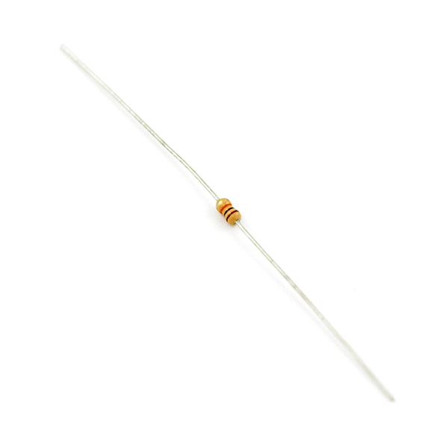

### Power Dissipation:

At any instant, the power P (watts) consumed by a resistor of resistance R (ohms) is calculated as: {\displaystyle P=I^{2}R=IV={\frac {V^{2}}{R}}}

 where V (volts) is the voltage across the resistor and I (amps) is the [current](https://en.wikipedia.org/wiki/Ampere) flowing through it. Using [Ohm's law](https://en.wikipedia.org/wiki/Ohm%27s_law), the two other forms can be derived. This power is converted into heat which must be dissipated by the resistor's package before its temperature rises excessively.

Resistors are rated according to their maximum power dissipation. Discrete resistors in solid-state electronic systems are typically rated as 1/10, 1/8, or 1/4 watt. They usually absorb much less than a watt of electrical power and require little attention to their power rating.

Resistors required to dissipate substantial amounts of power, particularly used in power supplies, power conversion circuits, and power amplifiers, are generally referred to as power resistors; this designation is loosely applied to resistors with power ratings of 1 watt or greater. Power resistors are physically larger and may not use the preferred values, color codes, and external packages described below.

If the average power dissipated by a resistor is more than its power rating, damage to the resistor may occur, permanently altering its resistance; this is distinct from the reversible change in resistance due to its [temperature coefficient](https://en.wikipedia.org/wiki/Temperature_coefficient) when it warms. Excessive power dissipation may raise the temperature of the resistor to a point where it can burn the circuit board or adjacent components, or even cause a fire. There are flameproof resistors that fail (open circuit) before they overheat dangerously.

Since poor air circulation, high altitude, or high [operating temperatures](https://en.wikipedia.org/wiki/Operating_temperature) may occur, resistors may be specified with higher rated dissipation than is experienced in service.

All resistors have a maximum voltage rating; this may limit the power dissipation for higher resistance values.

### Adjustable resistors:

A resistor may have one or more fixed tapping points so that the resistance can be changed by moving the connecting wires to different terminals. Some wire wound power resistors have a tapping point that can slide along the resistance element, allowing a larger or smaller part of the resistance to be used.

Where continuous adjustment of the resistance value during operation of equipment is required, the sliding resistance tap can be connected to a knob accessible to an operator. Such a device is called a [rheostat](https://en.wikipedia.org/wiki/Rheostat) and has two terminals.

### Resistance decade boxes:

A resistance decade box or resistor substitution box is a unit containing resistors of many values, with one or more mechanical switches which allow any one of various discrete resistances offered by the box to be dialed in. Usually the resistance is accurate to high precision, ranging from laboratory/calibration grade accuracy of 20 parts per million, to field grade at 1%. Inexpensive boxes with lesser accuracy are also available. All types offer a convenient way of selecting and quickly changing a resistance in laboratory, experimental and development work without needing to attach resistors one by one, or even stock each value. The range of resistance provided, the maximum resolution, and the accuracy characterize the box. For example, one box offers resistances from 0 to 100 megaohms, maximum resolution 0.1 ohm, accuracy 0.1%.

### Special devices:

There are various devices whose resistance changes with various quantities. The resistance of NTC [thermistors](https://en.wikipedia.org/wiki/Thermistor) exhibit a strong negative temperature coefficient, making them useful for measuring temperatures. Since their resistance can be large until they are allowed to heat up due to the passage of current, they are also commonly used to prevent excessive [current surges](https://en.wikipedia.org/wiki/Inrush_current) when equipment is powered on. Similarly, the resistance of a [hamster](https://en.wikipedia.org/wiki/Humistor) varies with humidity. One sort of photodetector, the [photo resistor](https://en.wikipedia.org/wiki/Photoresistor), has a resistance which varies with illumination.

The [strain gauge](https://en.wikipedia.org/wiki/Strain_gauge), invented by [Edward E. Simmons](https://en.wikipedia.org/wiki/Edward_E._Simmons) and [Arthur C. Ruge](https://en.wikipedia.org/wiki/Arthur_C._Ruge) in 1938, is a type of resistor that changes value with applied strain. A single resistor may be used, or a pair (half bridge), or four resistors connected in a [Wheatstone bridge](https://en.wikipedia.org/wiki/Wheatstone_bridge) configuration. The strain resistor is bonded with adhesive to an object that is subjected to [mechanical strain](https://en.wikipedia.org/wiki/Infinitesimal_strain_theory). With the strain gauge and a filter, amplifier, and analog/digital converter, the strain on an object can be measured.

A related but more recent invention uses a [Quantum Tunneling Composite](https://en.wikipedia.org/wiki/Quantum_Tunnelling_Composite) to sense mechanical stress. It passes a current whose magnitude can vary by a factor of 1012 in response to changes in applied pressure.

### Measurement:

The value of a resistor can be measured with an [ohmmeter](https://en.wikipedia.org/wiki/Ohmmeter), which may be one function of a [multimeter](https://en.wikipedia.org/wiki/Multimeter). Usually, probes on the ends of test leads connect to the resistor. A simple ohmmeter may apply a voltage from a battery across the unknown resistor (with an internal resistor of a known value in series) producing a current which drives a [meter movement](https://en.wikipedia.org/wiki/Galvanometer). The current, in accordance with [Ohm's law](https://en.wikipedia.org/wiki/Ohm%27s_law), is inversely proportional to the sum of the internal resistance and the resistor being tested, resulting in an analog meter scale which is very non-linear, calibrated from infinity to 0 ohms. A digital multimeter, using active electronics, may instead pass a specified current through the test resistance. The voltage generated across the test resistance in that case is linearly proportional to its resistance, which is measured and displayed. In either case the low-resistance ranges of the meter pass much more current through the test leads than do high-resistance ranges, in order for the voltages present to be at reasonable levels (generally below 10 volts) but still measurable.

Measuring low-value resistors, such as fractional-ohm resistors, with acceptable accuracy requires [four-terminal connections](https://en.wikipedia.org/wiki/Four-terminal_sensing). One pair of terminals applies a known, calibrated current to the resistor, while the other pair senses the voltage drop across the resistor. Some laboratory quality ohmmeters, especially milliohm meters, and even some of the better digital multimeters sense using four input terminals for this purpose, which may be used with special test leads. Each of the two so-called [Kelvin clips](https://en.wikipedia.org/wiki/Four-terminal_sensing) has a pair of jaws insulated from each other. One side of each clip applies the measuring current, while the other connections are only to sense the voltage drop. The resistance is again calculated using Ohm's Law as the measured voltage divided by the applied current.

### Color Code:

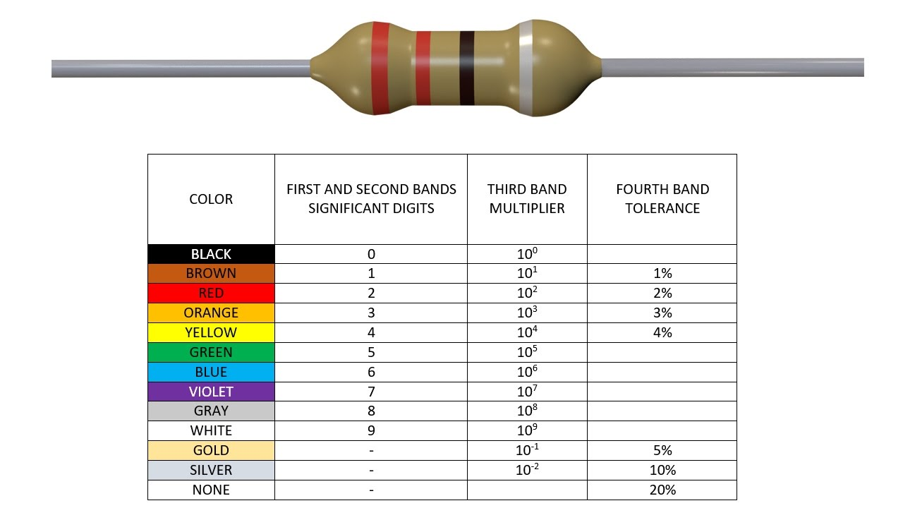

## Potentiometer:

A potentiometer is a three-[terminal](https://en.wikipedia.org/wiki/Terminal_(electronics)) [resistor](https://en.wikipedia.org/wiki/Resistor) with a sliding or rotating contact that forms an adjustable [voltage divider](https://en.wikipedia.org/wiki/Voltage_divider).[[1]](https://en.wikipedia.org/wiki/Potentiometer#cite_note-1) If only two terminals are used, one end and the wiper, it acts as a variable resistor or [rheostat](https://en.wikipedia.org/wiki/Potentiometer#Rheostat).

The measuring instrument called a [potentiometer](https://en.wikipedia.org/wiki/Potentiometer_(measuring_instrument)) is essentially a [voltage divider](https://en.wikipedia.org/wiki/Voltage_divider) used for measuring [electric potential](https://en.wikipedia.org/wiki/Electric_potential) (voltage); the component is an implementation of the same principle, hence its name.

Potentiometers are commonly used to control electrical devices such as volume controls on audio equipment. Potentiometers operated by a mechanism can be used as position [transducers](https://en.wikipedia.org/wiki/Transducer), for example, in a [joystick](https://en.wikipedia.org/wiki/Joystick). Potentiometers are rarely used to directly control significant power (more than a [watt](https://en.wikipedia.org/wiki/Watt)), since the power dissipated in the potentiometer would be comparable to the power in the controlled load.

A [potentiometer](https://en.wikipedia.org/wiki/Potentiometer) or pot is a three-terminal resistor with a continuously adjustable tapping point controlled by rotation of a shaft or knob or by a linear slider.[[19]](https://en.wikipedia.org/wiki/Resistor#cite_note-Mazda-19) It is called a potentiometer because it can be connected as an adjustable [voltage divider](https://en.wikipedia.org/wiki/Voltage_divider) to provide a variable [potential](https://en.wikipedia.org/wiki/Potential) at the terminal connected to the tapping point. A volume control for an audio device is a common use of a potentiometer. A typical low power potentiometer (see drawing) is constructed of a flat resistance element (B) of carbon composition, metal film, or conductive plastic, with a springy [phosphor bronze](https://en.wikipedia.org/wiki/Phosphor_bronze) wiper contact (C) which moves along the surface. An alternate construction is resistance wire wound on a form, with the wiper sliding axially along the coil.[[19]](https://en.wikipedia.org/wiki/Resistor#cite_note-Mazda-19) These have lower resolution, since as the wiper moves the resistance changes in steps equal to the resistance of a single turn.[[19]](https://en.wikipedia.org/wiki/Resistor#cite_note-Mazda-19)

High-resolution multiturn potentiometers are used in a few precision applications. These have wire wound resistance elements typically wound on a helical mandrel, with the wiper moving on a helical track as the control is turned, making continuous contact with the wire. Some include a conductive-plastic resistance coating over the wire to improve resolution. These typically offer ten turns of their shafts to cover their full range. They are usually set with dials that include a simple turns counter and a graduated dial, and can typically achieve three-digit resolution. Electronic analog computers used them in quantity for setting coefficients, and delayed-sweep oscilloscopes of recent decades included one on their panels.

### Construction:

Potentiometers consist of a [resistive element](https://en.wikipedia.org/wiki/Electrical_resistivity_and_conductivity), a sliding contact (wiper) that moves along the element, making good electrical contact with one part of it, electrical terminals at each end of the element, a mechanism that moves the wiper from one end to the other, and a housing containing the element and wiper.

See drawing. Many inexpensive potentiometers are constructed with a resistive element (B) formed into an arc of a circle usually a little less than a full turn and a wiper (C) sliding on this element when rotated, making electrical contact. The resistive element can be flat or angled. Each end of the resistive element is connected to a terminal (E, G) on the case. The wiper is connected to a third terminal (F), usually between the other two. On panel potentiometers, the wiper is usually the center terminal of three. For single-turn potentiometers, this wiper typically travels just under one revolution around the contact. The only point of ingress for contamination is the narrow space between the shaft and the housing it rotates in.

Another type is the linear slider potentiometer, which has a wiper which slides along a linear element instead of rotating. Contamination can potentially enter anywhere along the slot the slider moves in, making effective sealing more difficult and compromising long-term reliability. An advantage of the slider potentiometer is that the slider position gives a visual indication of its setting. While the setting of a rotary potentiometer can be seen by the position of a marking on the knob, an array of sliders can give a visual impression of, for example, the effect of a multi-band [equalizer](https://en.wikipedia.org/wiki/Equalization_(audio)) (hence the term "graphic equalizer").

The resistive element of inexpensive potentiometers is often made of [graphite](https://en.wikipedia.org/wiki/Graphite). Other materials used include resistance wire, carbon particles in plastic, and a ceramic/metal mixture called [cermet](https://en.wikipedia.org/wiki/Cermet). Conductive track potentiometers use conductive polymer resistor pastes that contain hard-wearing resins and polymers, solvents, and lubricant, in addition to the carbon that provides the conductive properties.

Others are enclosed within the equipment and are intended to be adjusted to calibrate equipment during manufacture or repair, and not otherwise touched. They are usually physically much smaller than user-accessible potentiometers, and may need to be operated by a screwdriver rather than having a knob. They are usually called "preset potentiometers" or "trim[ming] pots". Some presets are accessible by a small screwdriver poked through a hole in the case to allow servicing without dismantling.

Multiturn potentiometers are also operated by rotating a shaft, but by several turns rather than less than a full turn. Some multiturn potentiometers have a linear resistive element with a sliding contact moved by a lead screw; others have a [helical](https://en.wikipedia.org/wiki/Helix) resistive element and a wiper that turns through 10, 20, or more complete revolutions, moving along the helix as it rotates. Multiturn potentiometers, both user-accessible and preset, allow finer adjustments; rotation through the same angle changes the setting by typically a tenth as much as for a simple rotary potentiometer.

A [string potentiometer](https://en.wikipedia.org/wiki/String_potentiometer) is a multi-turn potentiometer operated by an attached reel of wire turning against a spring, enabling it to convert linear position to a variable resistance.

User-accessible rotary potentiometers can be fitted with a switch which operates usually at the anti-clockwise extreme of rotation. Before digital electronics became the norm such a component was used to allow radio and television receivers and other equipment to be switched on at minimum volume with an audible click, then the volume increased, by turning a knob. Multiple resistance elements can be ganged together with their sliding contacts on the same shaft, for example, in stereo audio amplifiers for volume control. In other applications, such as domestic light [dimmers](https://en.wikipedia.org/wiki/Dimmer), the normal usage pattern is best satisfied if the potentiometer remains set at its current position, so the switch is operated by a push action, alternately on and off, by axial presses of the knob.

### 10K Potentiometer:

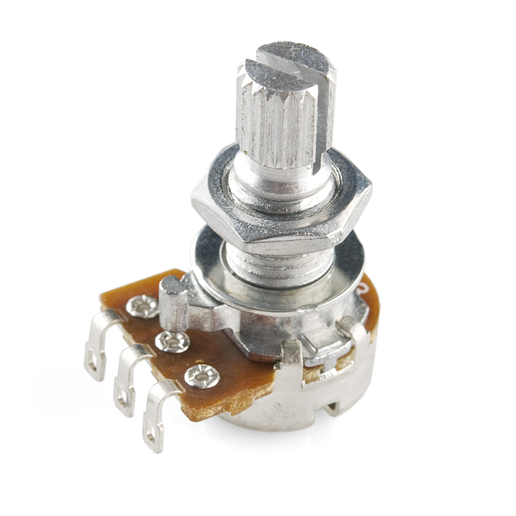

## White Light Emitting Diode:

A light-emitting diode (LED) is a two-[lead](https://en.wikipedia.org/wiki/Lead_(electronics)) [semiconductor](https://en.wikipedia.org/wiki/Semiconductor) [light source](https://en.wikipedia.org/wiki/Light_source). It is a [p–n junction](https://en.wikipedia.org/wiki/P%E2%80%93n_junction) [diode](https://en.wikipedia.org/wiki/Diode) that emits light when activated.[[5]](https://en.wikipedia.org/wiki/Light-emitting_diode#cite_note-5) When a suitable [current](https://en.wikipedia.org/wiki/Electric_current) is applied to the leads,[[6]](https://en.wikipedia.org/wiki/Light-emitting_diode#cite_note-6)[[7]](https://en.wikipedia.org/wiki/Light-emitting_diode#cite_note-7) [electrons](https://en.wikipedia.org/wiki/Electron) are able to recombine with [electron holes](https://en.wikipedia.org/wiki/Electron_hole) within the device, releasing energy in the form of [photons](https://en.wikipedia.org/wiki/Photon). This effect is called [electroluminescence](https://en.wikipedia.org/wiki/Electroluminescence), and the colour of the light (corresponding to the energy of the photon) is determined by the energy [band gap](https://en.wikipedia.org/wiki/Band_gap)of the semiconductor. LEDs are typically small (less than 1 mm2) and integrated optical components may be used to shape the [radiation pattern](https://en.wikipedia.org/wiki/Radiation_pattern).[[8]](https://en.wikipedia.org/wiki/Light-emitting_diode#cite_note-8)

Appearing as practical electronic components in 1962, the earliest LEDs emitted low-intensity infrared light.[[9]](https://en.wikipedia.org/wiki/Light-emitting_diode#cite_note-FirstPracticalLED-9) Infrared LEDs are still frequently used as transmitting elements in remote-control circuits, such as those in remote controls for a wide variety of consumer electronics. The first visible-light LEDs were of low intensity and limited to red. Modern LEDs are available across the [visible](https://en.wikipedia.org/wiki/Visible_spectrum), [ultraviolet](https://en.wikipedia.org/wiki/Ultraviolet), and [infrared](https://en.wikipedia.org/wiki/Infrared) wavelengths, with very high brightness.

Early LEDs were often used as indicator lamps for electronic devices, replacing small incandescent bulbs. They were soon packaged into numeric readouts in the form of [seven-segment displays](https://en.wikipedia.org/wiki/Seven-segment_display) and were commonly seen in digital clocks. Recent developments have produced LEDs suitable for environmental and task lighting. LEDs have led to new displays and sensors, while their high switching rates are useful in advanced communications technology.

LEDs have many advantages over incandescent light sources, including lower energy consumption, longer lifetime, improved physical robustness, smaller size, and faster switching. Light-emitting diodes are used in applications as diverse as [aviation lighting](https://en.wikipedia.org/wiki/Navigation_light#Aviation_navigation_lights), [automotive headlamps](https://en.wikipedia.org/wiki/Automotive_lighting#Light_emitting_diodes_(LED)), advertising, [general lighting](https://en.wikipedia.org/wiki/Lighting), [traffic signals](https://en.wikipedia.org/wiki/Traffic_signal), camera flashes, lighted wallpaper and medical devices.[[10]](https://en.wikipedia.org/wiki/Light-emitting_diode#cite_note-Aguilar-10) They are also significantly more energy efficient and, arguably, have fewer environmental concerns linked to their disposal.[[11]](https://en.wikipedia.org/wiki/Light-emitting_diode#cite_note-cfl-epa-11)[[12]](https://en.wikipedia.org/wiki/Light-emitting_diode#cite_note-12)

Unlike a [laser](https://en.wikipedia.org/wiki/Laser), the color of light emitted from an LED is neither coherent nor monochromatic, but the spectrum is narrow with respect to human vision, and for most purposes the light from a simple diode element can be regarded as functionally monochromatic.

## Wires:

A **wire** is a single, usually cylindrical, flexible strand or rod of metal. **Wires** are used to bear mechanical loads or electricity and telecommunications signals. **Wire** is commonly formed by drawing the metal through a hole in a die or draw plate. ...**Wire** comes in solid core, stranded, or braided forms.

## Power Supply:

A power supply is an electrical device that supplies [electric power](https://en.wikipedia.org/wiki/Electric_power) to an [electrical load](https://en.wikipedia.org/wiki/Electrical_load). The primary function of a power supply is to convert [electric current](https://en.wikipedia.org/wiki/Electric_current) from a source to the correct [voltage](https://en.wikipedia.org/wiki/Voltage), [current](https://en.wikipedia.org/wiki/Electric_current), and [frequency](https://en.wikipedia.org/wiki/Frequency) to power the load. As a result, power supplies are sometimes referred to as [electric power converters](https://en.wikipedia.org/wiki/Electric_power_converter). Some power supplies are separate standalone pieces of equipment, while others are built into the load appliances that they power. Examples of the latter include power supplies found in [desktop computers](https://en.wikipedia.org/wiki/Desktop_computer) and [consumer electronics](https://en.wikipedia.org/wiki/Consumer_electronics) devices. Other functions that power supplies may perform include limiting the current drawn by the load to safe levels, shutting off the current in the event of an [electrical fault](https://en.wikipedia.org/wiki/Electrical_fault), power conditioning to prevent [electronic noise](https://en.wikipedia.org/wiki/Electronic_noise) or [voltage surges](https://en.wikipedia.org/wiki/Voltage_surge) on the input from reaching the load, [power-factor correction](https://en.wikipedia.org/wiki/Power-factor_correction), and storing energy so it can continue to power the load in the event of a temporary interruption in the source power ([uninterruptible power supply](https://en.wikipedia.org/wiki/Uninterruptible_power_supply)).

All power supplies have a power input connection, which receives energy in the form of electric current from a source, and one or more power output connections that deliver current to the load. The source power may come from the [electric power grid](https://en.wikipedia.org/wiki/Electric_power_grid), such as an [electrical outlet](https://en.wikipedia.org/wiki/Electrical_outlet), [energy storage](https://en.wikipedia.org/wiki/Energy_storage) devices such as [batteries](https://en.wikipedia.org/wiki/Battery_(electricity)) or [fuel cells](https://en.wikipedia.org/wiki/Fuel_cell), [generators](https://en.wikipedia.org/wiki/Electrical_generators) or [alternators](https://en.wikipedia.org/wiki/Alternator), [solar power](https://en.wikipedia.org/wiki/Solar_power) converters, or another power supply. The input and output are usually hardwired circuit connections, though some power supplies employ [wireless energy transfer](https://en.wikipedia.org/wiki/Wireless_power) to power their loads without wired connections. Some power supplies have other types of inputs and outputs as well, for functions such as external monitoring and control.

A power supply is an electrical device that supplies [electric power](https://en.wikipedia.org/wiki/Electric_power) to an [electrical load](https://en.wikipedia.org/wiki/Electrical_load). The primary function of a power supply is to convert [electric current](https://en.wikipedia.org/wiki/Electric_current) from a source to the correct [voltage](https://en.wikipedia.org/wiki/Voltage), [current](https://en.wikipedia.org/wiki/Electric_current), and [frequency](https://en.wikipedia.org/wiki/Frequency) to power the load. As a result, power supplies are sometimes referred to as [electric power converters](https://en.wikipedia.org/wiki/Electric_power_converter). Some power supplies are separate standalone pieces of equipment, while others are built into the load appliances that they power. Examples of the latter include power supplies found in [desktop computers](https://en.wikipedia.org/wiki/Desktop_computer) and [consumer electronics](https://en.wikipedia.org/wiki/Consumer_electronics) devices. Other functions that power supplies may perform include limiting the current drawn by the load to safe levels, shutting off the current in the event of an [electrical fault](https://en.wikipedia.org/wiki/Electrical_fault), power conditioning to prevent [electronic noise](https://en.wikipedia.org/wiki/Electronic_noise) or [voltage surges](https://en.wikipedia.org/wiki/Voltage_surge) on the input from reaching the load, [power-factor correction](https://en.wikipedia.org/wiki/Power-factor_correction), and storing energy so it can continue to power the load in the event of a temporary interruption in the source power ([uninterruptible power supply](https://en.wikipedia.org/wiki/Uninterruptible_power_supply)).

All power supplies have a power input connection, which receives energy in the form of electric current from a source, and one or more power output connections that deliver current to the load. The source power may come from the [electric power grid](https://en.wikipedia.org/wiki/Electric_power_grid), such as an [electrical outlet](https://en.wikipedia.org/wiki/Electrical_outlet), [energy storage](https://en.wikipedia.org/wiki/Energy_storage) devices such as [batteries](https://en.wikipedia.org/wiki/Battery_(electricity)) or [fuel cells](https://en.wikipedia.org/wiki/Fuel_cell), [generators](https://en.wikipedia.org/wiki/Electrical_generators) or [alternators](https://en.wikipedia.org/wiki/Alternator), [solar power](https://en.wikipedia.org/wiki/Solar_power) converters, or another power supply. The input and output are usually hardwired circuit connections, though some power supplies employ [wireless energy transfer](https://en.wikipedia.org/wiki/Wireless_power) to power their loads without wired connections. Some power supplies have other types of inputs and outputs as well, for functions such as external monitoring and control.

## 9V Battery:

The nine-volt battery, or 9-volt battery, is a common size of battery that was introduced for the early [transistor radios](https://en.wikipedia.org/wiki/Transistor_radio). It has a rectangular prism shape with rounded edges and a polarized snap connector at the top. This type is commonly used in [walkie-talkies](https://en.wikipedia.org/wiki/Walkie-talkie), [clocks](https://en.wikipedia.org/wiki/Clock) and [smoke detectors](https://en.wikipedia.org/wiki/Smoke_detector).

The nine-volt battery format is commonly available in primary carbon-zinc and alkaline chemistry, in primary lithium iron disulfide, and in rechargeable form in nickel-cadmium, nickel-metal hydride and lithium-ion. Mercury-oxide batteries of this format, once common, have not been manufactured in many years due to their mercury content. [Designations](https://en.wikipedia.org/wiki/Battery_nomenclature) for this format include NEDA 1604 and IEC 6F22 (for zinc-carbon) or MN1604 6LR61 (for alkaline). The size, regardless of chemistry, is commonly designated PP3—a designation originally reserved solely for carbon-zinc, or in some countries, E or E-block.

Most nine-volt alkaline batteries are constructed of six individual 1.5 V LR61 cells enclosed in a wrapper These cells are slightly smaller than LR8D425 [AAAA cells](https://en.wikipedia.org/wiki/AAAA_battery) and can be used in their place for some devices, even though they are 3.5 mm shorter. Carbon-zinc types are made with six flat cells in a stack, enclosed in a moisture-resistant wrapper to prevent drying. Primary lithium types are made with three cells in series.

In 2007, 9-volt batteries accounted for 4% of alkaline primary battery sales in the US. In Switzerland in 2008, 9-volt batteries totaled 2% of primary battery sales and 2% of secondary battery sale.

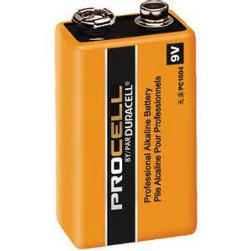

# **Project Cost:**

The Total Cost on this project is ______. However, the estimated cost of the project was about _____.